Given Name Last Name, , Given Name Last Name & Given Name Last Name (City)

Main title – no more than two lines, please

Abstract
Text of abstract in English [max. 700 characters] Text of abstract in English [max. 700 characters] Text of abstract in English [max. 700 characters] Text of abstract in English [max. 700 characters] Text of abstract in English [max. 700 characters] Text of abstract in English [max. 700 characters] Text of abstract in English [max. 700 characters] Text of abstract in English [max. 700 characters] Text of abstract in English [max. 700 characters] Text of abstract in English [max. 700 characters] Text of abstract in English [max. 700 characters] Text of abstract in English [max. 700 characters] Text of abstract in English [max. 700 characters] Text of abstract in English [max. 700 characters] Text of abstract in English [max. 700 characters]

Keywords
keywords in English, keywords in English, keywords in English, keywords in English, keywords in English [max. 5]

Titel (in Deutsch) – dieser sollte sich bitte auf zwei Zeilen beschränken

Zusammenfassung
Text der Zusammenfassung (max. 700 Zeichen) Text der Zusammenfassung (max. 700 Zeichen) Text der Zusammenfassung (max. 700 Zeichen) Text der Zusammenfassung (max. 700 Zeichen) Text der Zusammenfassung (max. 700 Zeichen) Text der Zusammenfassung (max. 700 Zeichen) Text der Zusammenfassung (max. 700 Zeichen) Text der Zusammenfassung (max. 700 Zeichen) Text der Zusammenfassung (max. 700 Zeichen) Text der Zusammenfassung (max. 700 Zeichen) Text der Zusammenfassung (max. 700 Zeichen) Text der Zusammenfassung (max. 700 Zeichen) Text der Zusammenfassung (max. 700 Zeichen) Text der Zusammenfassung (max. 700 Zeichen) Text der Zusammenfassung (max. 700 Zeichen) Text der Zusammenfassung (max. 700 Zeichen)

Schlüsselwörter
Schlüsselwörter auf Deutsch, Schlüsselwörter auf Deutsch, Schlüsselwörter auf Deutsch, Schlüsselwörter auf Deutsch, Schlüsselwörter auf Deutsch [max. 5]

1 Header 1
This is an example of continuous text paragraphs. Please include a short citation in parentheses when quoting literature. For example, if you use a direct quote: “This is an example of a direct quote” (Last name & Last name, 2005, p. 21). If you are paraphrasing, please put a “cf” in front (cf. Last name, 2021).
- this is an example for an unnumbered list
- this is an example for an unnumbered list
- this is an example for an unnumbered list

Illustrations are placed within the text. They should also be provided separately, preferably in high resolution. Please refer to the numbered illustrations in your text (see Figure 1). Avoid phrases such as “on the following page”, “following” or similar, as the placement may shift due to typesetting.

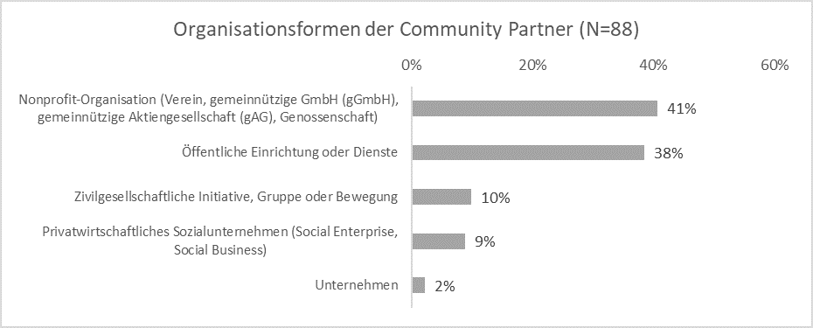
Fig. 1: Title figure 1

2 Header 1

2.1 Header 2
This is an example of continuous text paragraphs. Please include a short citation in parentheses when quoting literature. For example, if you use a direct quote: “This is an example of a direct quote” (Last name & Last name, 2005, p. 21). If you are paraphrasing, please put a “cf” in front (cf. Last name, 2021). Longer quotations can also be set off in the text. Please use the template “zfhe_zitat”:
“The quote should begin and end with a quotation mark and be at least four lines long. The quote should begin and end with a quotation mark and be at least four lines long. The quote should begin and end with a quotation mark and be at least four lines long. The quote should begin and end with a quotation mark and be at least four lines long. The quote should begin and end with a quotation mark and be at least four lines long.”
This is an example of continuous text paragraphs. Please include a short citation in parentheses when quoting literature. For example, if you use a direct quote: “This is an example of a direct quote” (Last name & Last name, 2005, p. 21). If you are paraphrasing, please put a “cf” in front (cf. Last name, 2021).
- this is an example for a numbered list
- this is an example for a numbered list
- this is an example for a numbered list

3.2.1 Header 3
This is an example of continuous text paragraphs. Please include a short citation in parentheses when quoting literature. For example, if you use a direct quote: “This is an example of a direct quote” (Last name & Last name, 2005, p. 21). If you are paraphrasing, please put a “cf” in front (cf. Last name, 2021).

3.2.2.1 Header 4
This is an example of continuous text paragraphs. Please include a short citation in parentheses when quoting literature. For example, if you use a direct quote: “This is an example of a direct quote” (Last name & Last name, 2005, p. 21). If you are paraphrasing, please put a “cf” in front (cf. Last name, 2021).

4 Notes on citation
Die ZFHE verwendet die APA-Zitierrichtlinien, 7. Auflage. Bitte geben Sie unbedingt, wo vorhanden, auch die URL oder den DOI an. Im folgenden Literaturverzeichnis finden Sie Beispiele für die gängisten Zitationen.

5 References
Koch, T. (2010). Macht der Gewohnheit? Der Einfluss der Habitualisierung auf die Fern-sehnutzung. VS Verlag für Sozialwissenschaften. https://doi.org/10.1007/978-3-531-92529-5
Horton, D., & Wohl, R. R. (1956). Mass communication and para-social interaction: Observa-tions on intimacy at a distance. Psychiatry, 19(3), 215–229. https://doi.org/10.1080/00- 332747.1956.11023049
Huta, V. (2017). An overview of hedonic and eudaimonic well-being concepts. In L. Reinecke & M. B. Oliver (Hrsg.), The Routledge handbook of media use and well-being. International perspectives on theory and research on positive media effects (S. 14–33). Routledge.
Roller-Spoo, J. (2020, 24. Oktober). Von Hatern und Hetzern: Der Kampf gegen Hass im Netz. ZDF heute–Nachrichten. https://www.zdf.de/nachrichten/digitales/hate-speech-hass-ge-walt-internet-100.html

Corresponding author: E-Mail-adress
Affiliation; E-Mail; ORCiD
Affiliation; E-Mail; ORCiD
Affiliation; E-Mail; ORCiD
This is a footnote.
Here are some quick guides: Uni Mainz: Zitieren gemäß APA (7th Edition) - Kurz-Manual; Uni Graz: Zitieren im Text nach APA Richtlinien (7. Auflage).

